Define an GUI interface that covers the functions required by BAB with regards to printing Z and X reports and Check copy printing. Micros is not being used anymore, all functions have to retrieve information from the Star or Citizen printers fiscal memory. The functions need to save files to the c:/fbook folder or print them. File specs are also in this document.

requirements

Z + X report, printing to file or to printer
- Print todays z report (and closing the zreport by doing this)
- Print a previous z report by number range
- Print a previous z report by date range
- Print a x report

Print a check copy
- Enter document number to print (wrap in a NO SALE template)

Config
- Verify port connection
Define the File format for the fbook (hardcoded)

Salesbook specs
The BAB requires to close a day with a z report. And has defined the requirements for this piece of software.

47 | Print an X-report
48 | Print a Z-report
49 | Verify that a Z-report on paper is optional. (to fbook)
50 | a series of Z-reports can be printer by date ranges
51 | a series of Z-reports can be printer by Z-numbers
52
56 | Print a document and verify that the correlative of the NSF
57 | Verify that the NO SALE documents meet the following requirements:  a) 100 lines maximum  b) The NO SALE document must be concluded with the following line: *** END NO SALE DOCUMENT***

58 | Check copy printing functionality:  a) At least one copy can be printed  b) The copy has to appear on a NO SALE document

53: (sales book): Verify that a Z-report is NOT generated when the date changes on the fiscal device

Batfile from company Proffid to generate salesbook files
@echo off
set fbook_dir=c:\FBOOK
goto menu
:info_help
color 74
title Salesbook Exporter information
cls
echo SALESBOOK EXPORTER INFORMATION - NOVEMEBER 2104
echo .
echo . This Menu has been written bij Gertjan Roelofs - Proffid Caribbean NV
echo .
echo . It's sole purpose is to run the SBAB Salesbook Export correctly.
echo .
echo . Before running any of the options, please make sure you ran your z-report on
echo . all machines that have a fiscal printer attached.
echo .
echo . also make sure that all your fiscal printers are turned on.
echo .
echo . The export files you will generate are placed in a folder %fbook_dir%
echo .
echo . You can open these files with wordpad, excell, but cannot change them due
echo . to the encryptes Checksum in the files.
echo . change any figure and SBAB will find out you changed the export fields
echo .
echo . These export files, mainly the monthly export is to be uploaded into SBAB
echo . Website that will be made available.
echo.
echo.
pause
echo .
echo . if you get an error with exporter from Micros, make sure you entered date
echo . or month correctly: 1st of February 2014 will be 01/02/2014 and not 1/2/14
echo .
echo . same goes for month export, use 01 ,02 ,03 ......12 for the month
echo .
echo . If you get an error with the Epson exporter (TestDll.exe) ,
echo . make sure Micros POS operations is closed and not running,
echo . and under Epson Exporter configuration settings you selected the extencion checkmark
echo . with extention txt
echo . the Epson Exporter requires to be run as an administrator in general.
echo . Make sure you use the 32 or 64 bits version correctly.
echo .
pause
:menu
color 97
title Salesbook Exporter
cls
echo.
echo.
echo ================== Menu ===================
echo * *
echo * Before exporting make sure you *
echo * *
echo * Performed your z-report on all machines *
echo * *
echo * 1 - Generate Daily Salesbook Micros *
echo * *
echo * 2 - Generate Monthly Salesbook Micros *
echo * *
echo * 3 - Generate Salesbook Epson *
echo * *
echo * h - Information *
echo * *
echo * x - Exit *
echo * *
echo ===========================================
echo.
echo Select the type of service command to run
echo.
set /p menutype= Your selection:

if '%menutype%'=='1' goto select_date
if '%menutype%'=='2' goto select_month
if '%menutype%'=='3' goto select_epson
if '%menutype%'=='h' goto info_help
if '%menutype%'=='H' goto info_help
if '%menutype%'=='x' exit
if '%menutype%'=='X' exit

:select_date
cls
title Select date for export
cls
echo.
echo.
echo ================== Menu ===================
echo * *
echo * Select Date in DD/MM/YYYY format *
echo * *
echo * x - Exit *
echo * *
echo ===========================================
echo.
echo Select the type of service command to run
echo.
set /p begin_date= Your selection:

if '%begin_date%'=='x' goto end
if '%begin_date%'=='X' goto end

set end_date=%begin_date%

goto daily_export

:select_month

cls
title Month Export
cls
echo.
echo.
echo ================== Menu ===================
echo * *
echo * *
echo * Enter the Month Number ( MM ) *
echo * 2 digits *
echo * x - Exit *
echo * *
echo ===========================================
echo Ctrl+C at any time will abort
echo.
echo.
echo Select the type of service command to run
echo.
set /p exp_month= Your selection:

if '%exp_month%'=='x' goto end
if '%exp_month%'=='X' goto end
if '%exp_month%'=='01' set lastday_month=31
if '%exp_month%'=='02' set lastday_month=28
if '%exp_month%'=='03' set lastday_month=31
if '%exp_month%'=='04' set lastday_month=30
if '%exp_month%'=='05' set lastday_month=31
if '%exp_month%'=='06' set lastday_month=30
if '%exp_month%'=='07' set lastday_month=31
if '%exp_month%'=='08' set lastday_month=31
if '%exp_month%'=='09' set lastday_month=30
if '%exp_month%'=='10' set lastday_month=31
if '%exp_month%'=='11' set lastday_month=31
if '%exp_month%'=='12' set lastday_month=30

select_year
cls
title Select Year for Month Export
cls
echo.
echo.
echo ================== Menu ===================
echo * *
echo * *
echo * Enter the year Number (YYYY) *
echo * *
echo * x - Exit *
echo * *
echo ===========================================
echo Ctrl+C at any time will abort
echo.
echo.
echo Select the type of service command to run
echo.
set /p exp_year= Your selection:

if '%exp_year%'=='x' goto end
if '%exp_year%'=='X' goto end

:monthly_export
if not exist %fbook_dir% md %fbook_dir%
if not exist %fbook_dir%\%exp_year% md %fbook_dir%\%exp_year%
if not exist %fbook_dir%\%exp_year%\%exp_month% md %fbook_dir%\%exp_year%\%exp_month%

salesbook.exe 01/%exp_month%/%exp_year% %lastday_month%/%exp_month%/%exp_year%

move %fbook_dir%\SB*.* %fbook_dir%\%exp_year%\%exp_month%
del %fbook_dir%\%exp_year%\%exp_month%\SB1?????.001
%systemroot%\explorer.exe %fbook_dir%\%exp_year%\%exp_month%
goto menu

:daily_export
if not exist %fbook_dir% md %fbook_dir%
if not exist %fbook_dir%\%begin_date:~-4,4% md %fbook_dir%\%begin_date:~-4,4%
if not exist %fbook_dir%\%begin_date:~-4,4%\%begin_date:~-7,2% md %fbook_dir%\%begin_date:~-4,4%\%begin_date:~-7,2%
if not exist %fbook_dir%\%begin_date:~-4,4%\%begin_date:~-7,2%\%begin_date:~-10,2% md %fbook_dir%\%begin_date:~-4,4%\%begin_date:~-7,2%\%begin_date:~-10,2%
salesbook.exe %begin_date% %end_date%
move %fbook_dir%\SB*.* %fbook_dir%\%begin_date:~-4,4%\%begin_date:~-7,2%\%begin_date:~-10,2%

%systemroot%\explorer.exe %fbook_dir%\%begin_date:~-4,4%\%begin_date:~-7,2%\%begin_date:~-10,2%
goto menu

:select_epson
testdllapp.exe
cls
goto menu

goto menu
:end

Elepos Vmax
The ‘reports and audit’ tab has most functions that salesbook need.

Screenshot from elepos vpanel
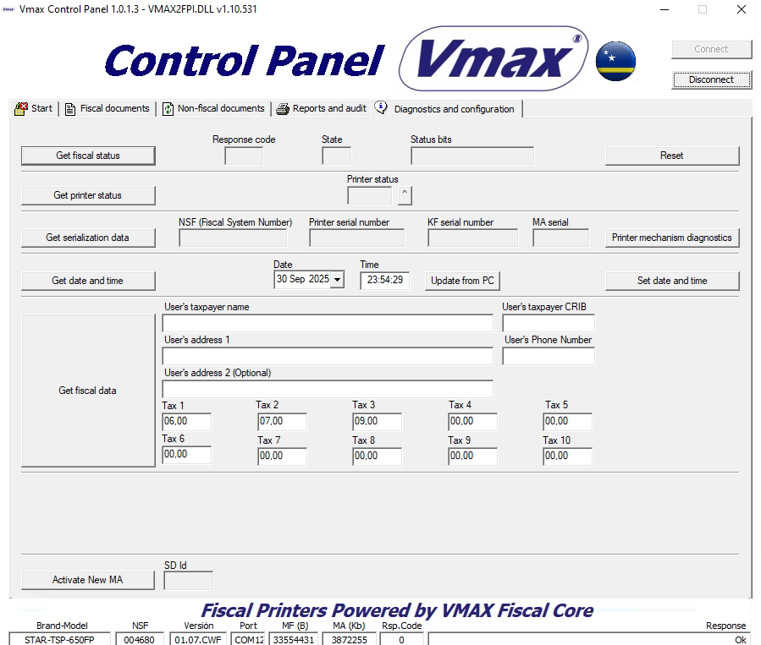

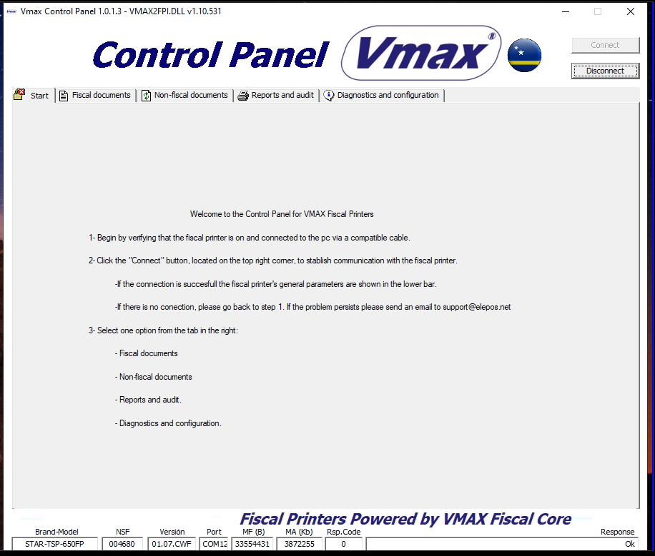
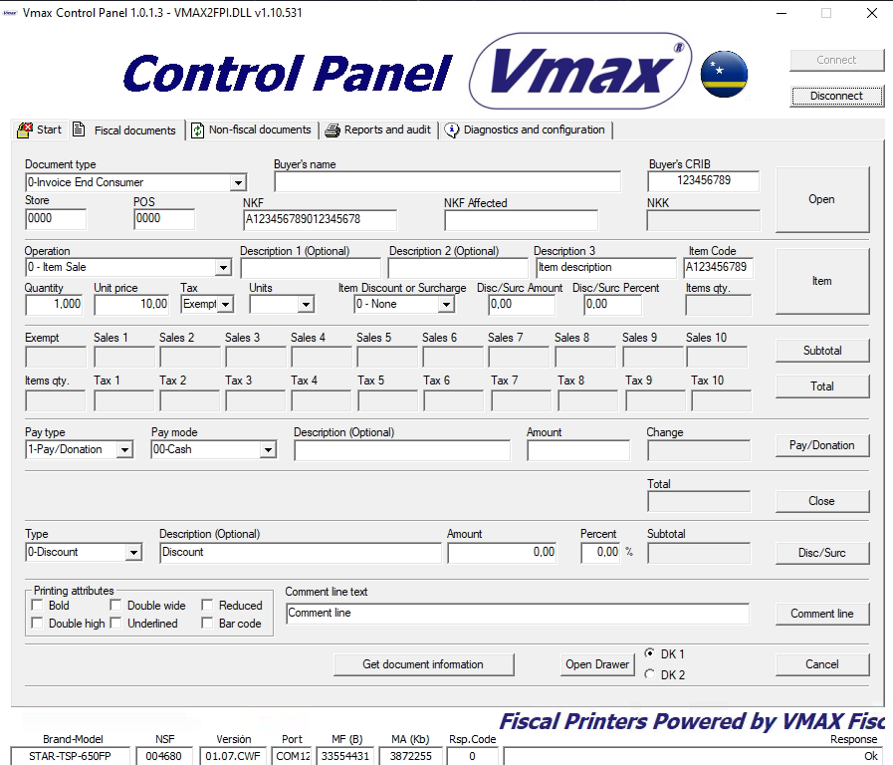

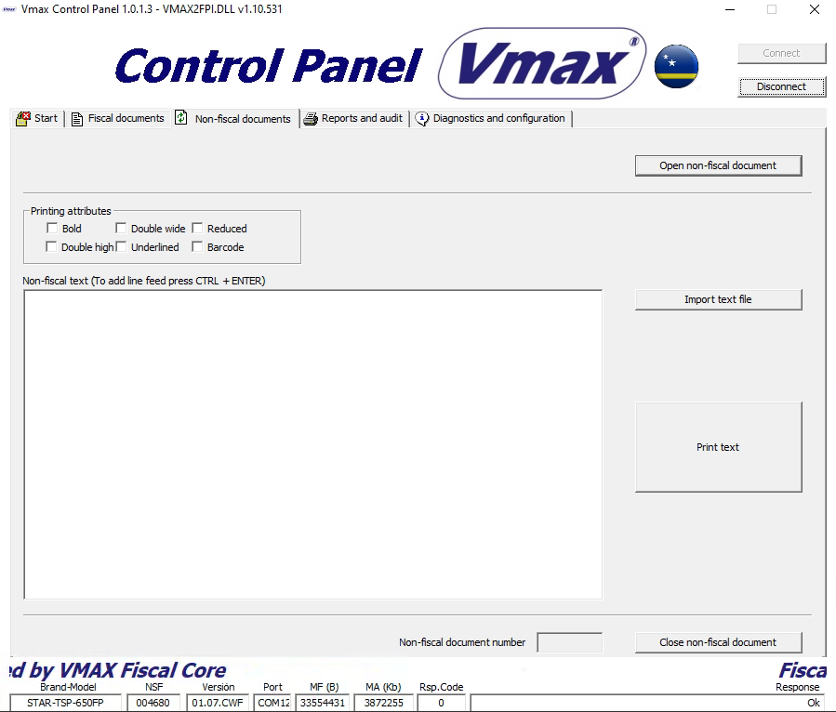
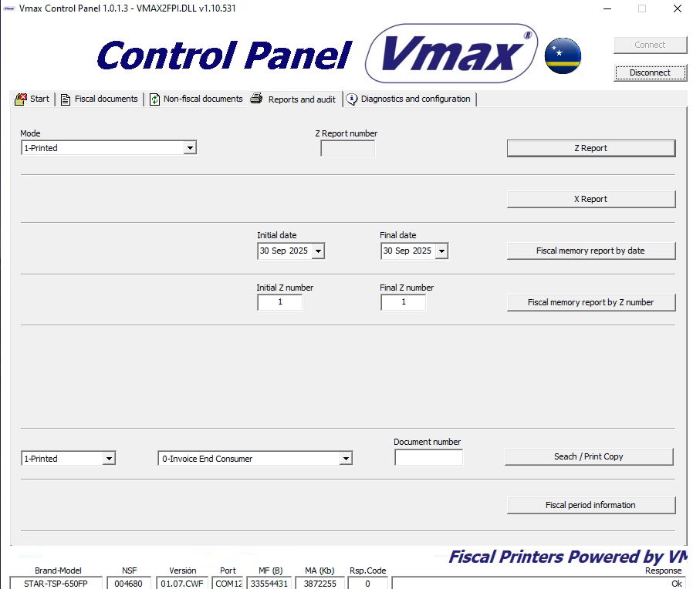

Elepos salesbook
This salesbook UI from elepos/vmax comes close, but misses the Z report functions.
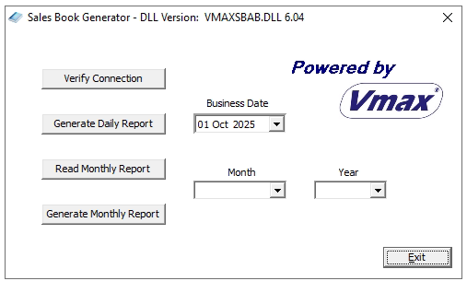

STRUCTURE OF MONTHLY SALES BOOK

Modifications Log
Date | Modification
15 nov 2013 | Number Komprobante Fiskal (NKF) has been reduced from 20 positions to 19. NKF construction:  - Source of document (1 character)  - cribnumber (9 digits)  - Specific cash register/printer (in specific branch) number (2 digits)  - Type of receipt/invoice (1 digit)  - Sequential number (6 digits)
15 nov 2013 | Change in text: NCF (Número de Comprobante Fiscal) in description is modified to NKF (Number di Komprobante Fiskal) as mentioned on the invoice and credit note format.
15 nov 2013 | NKK (Number Konsekutivo di Kaha) as mentioned on the format of the invoice and credit note is added to name ‘NIF’ (Número de Impresora Fiscal).

1. SALES BOOKS

1.1 MONTHLY SALES BOOK

Features:

The field separator is ||.
Empty fields are represented by blanks.
The maximum number of decimal places is 2.

1.1.1 File Header Monthly Book Sales:

Consists of a single line with the following data:

 | Name | Comments | Length | Type
1 | Line ID | Identifies de line type.  For this line the identifier is: 3. | 1 | Numeric
2 | HASH | The algorithm SHA-1 has to be used.  To generate the HASH, take into account all lines of the file, including the HASH from the  daily electronic journals. | 160 bits | Character
3 | Number of records | Number of records recorded in the file. Number of lines 2 (transactions). | 10 | Numeric
4 | Total Amount File | Total value of all sales recorded in the file. Regardless of the type of document or sub  document type. | 14,2 | Numeric
5 | Total IVA Amount  File | Total amount of IVA of all sales recorded in  the file.  Regardless of the type of document or sub document type. | 14,2 | Numeric
6 | Total IVA Amount  File  Tax 1 | Total amount of IVA of all sales recorded in  the file.  Regardless of the type of document or sub document type. | 14,2 | Numeric
7 | Total IVA Amount  File  Tax 2 | Total amount of IVA of all sales recorded in  the file.  Regardless of the type of document or sub document type. | 14,2 | Numeric

8 | Total IVA Amount  File  Tax 3 | Total amount of IVA of all sales recorded in the file.  Regardless of the type of document or sub document type. | 14,2 | Numeric
9 | Total Amount  Final Consumer | Total value of all sales to final consumers  recorded in the file.  Regardless of the type of document or sub document type. | 14,2 | Numeric
10 | IVA Amount  Final Consumer | Total amount of the IVA on all sales to final  consumers recorded in the file.  Regardless of the type of document or sub document type. | 14,2 | Numeric
11 | Total Amount  Fiscal Credit | Total amount of all sales tax credit recorded  in the file.  Regardless of the type of document or sub document type. | 14,2 | Numeric
12 | IVA Amount  Sales Fiscal  Credit | Total amount of the IVA on all sales tax credit  recorded in the file.  Regardless of the type of document or sub document type. | 14,2 | Numeric
13 | Credit Note  Amount  Final Consumer | Total amount of all credit notes for final  consumer recorded in the file.  Regardless of the type of document or sub document type. | 14,2 | Numeric
14 | IVA Amount  Credit Note  Final Consumer | Total amount of the IVA on all credit notes for  final consumer recorded in the file. Regardless of the type of document or sub document type. | 14,2 | Numeric
15 | Credit Note  Amount  Fiscal Credit | Total amount of all credit notes of fiscal credit  recorded in the file.  Regardless of the type of document or sub document type. | 14,2 | Numeric
16 | IVA Amount  Credit Note  Fiscal Credit | Total amount of the IVA on all credit notes of  fiscal credit recorded in the file.  Regardless of the type of document or sub document type. | 14,2 | Numeric

1.1.2 Header Daily Sales Book:

Consists of a single line with the following data:

 | Name | Comments | Length | Type
1 | Line ID | Identifies de line type.  For this line the identifier is: 1. | 1 | Numeric
2 | HASH | The algorithm SHA-1 has to be used.  To generate the HASH, take into account all lines of the file, including the HASH from the  daily electronic journals. | 160 bits | Character
3 | Fiscal Device ID | Fiscal Device Unique Identifier. | 6 | Numeric
4 | Number of  records | Number of records recorded in the file.  Number of lines 2 (transactions). | 10 | Numeric
5 | Total Amount File | Total amount of all sales recorded in the file.  Total of all transactions (total of all lines 2). Regardless of the type of document or sub document type. | 14,2 | Numeric
6 | Total IVA Amount  File | Total amount of IVA of all sales recorded in  the file.  Total IVA of all transactions (total IVA of all lines 2).  Regardless of the type of document or sub  document type. | 14,2 | Numeric
7 | Total IVA Amount  File  Tax 1 | Total amount of IVA of all sales recorded in  the file with tax 1.  Total IVA charged on all transactions (total  IVA of all lines 2) with tax 1.  Regardless of the type of document or sub document type. | 14,2 | Numeric
8 | Total IVA Amount  File  Tax 2 | Total amount of IVA of all sales recorded in  the file with tax 2.  Total IVA charged on all transactions (total  IVA of all lines 2) with tax 2.  Regardless of the type of document or sub document type. | 14,2 | Numeric
9 | Total IVA Amount  File  Tax 3 | Total amount of IVA of all sales recorded in  the file with tax 3.  Total IVA charged on all transactions (total  IVA of all lines 2) with tax 3.  Regardless of the type of document or sub document type. | 14,2 | Numeric

10 | Total Amount  Final Consumer | Total value of all sales to final consumers recorded in the file.  Regardless of the type of document or sub document type. | 14,2 | Numeric
11 | IVA Amount  Final Consumer | Total amount of IVA of all sales to final  consumer recorded in the file.  Regardless of the type of document or sub document type. | 14,2 | Numeric
12 | Accumulated  amount  Final Consumer | Total accumulated in sales to final consumers  corresponding to that recorded in the report Z. | 14,2 | Numeric
13 | Sale Amount  Fiscal Credit | Total amount of all sales tax credit recorded in the file.  Regardless of the type of document or sub document type. | 14,2 | Numeric
14 | IVA Amount  Sales Fiscal  Credit | Total amount IVA of all sales fiscal credit recorded in the file.  Regardless of the type of document or sub document type. | 14,2 | Numeric
15 | Accumulated  Amount  Sale Fiscal Credit | Total accumulated in sales fiscal credit corresponding to that recorded in the report Z. | 14,2 | Numeric
16 | Credit Note  Amount  Final Consumer | Total amount of all notes credit for final  consumer recorded in the file.  Regardless of the type of document or sub  document type. | 14,2 | Numeric
17 | IVA Amount  Credit Note  Final Consumer | Total amount IVA of all notes credit for final  consumer recorded in the file.  Regardless of the type of document or sub document type. | 14,2 | Numeric
18 | Accumulated  Amount Credit Note Final Consumer | Total accumulated in credit notes for final  consumer corresponding to that recorded in the report Z. | 14,2 | Numeric
19 | Amount Credit  Note  Fiscal Credit | Total amount of all credit note of fiscal credit  recorded in the file.  Regardless of the type of document or sub document type. | 14,2 | Numeric
20 | Amount IVA  Credit Note Of  Fiscal Credit | Total amount IVA of all credit note of fiscal  credit recorded in the file.  Regardless of the type of document or sub document type. | 14,2 | Numeric

21 | Accumulated  Amount  Credit Note Of  Fiscal Credit | Total accumulated in credit notes of fiscal credit corresponding to that recorded in the  report Z. | 14,2 | Numeric
22 | Number of  Documents No  Sales | Total of documents no sales recorded in the  file. | 10 | Numeric
23 | Initial NIF Number  (NKK on invoice) | Initial NIF number of documents recorded in the file.  Regardless of the type of document or sub document type.  6 (Fiscal device unique identifier) +  10 (correlative). | 6+10=16 | Numeric
24 | Final NIF Number  (NKK on invoice) | Final NIF number of documents recorded in the file.  Regardless of the type of document or sub document type.  6 (Fiscal device unique identifier) +  10 (correlative). | 6+10=16 | Numeric
25 | Report Z Number | Report Z number corresponding. | 20 | Character
26 | Name Of Program  Provider | Name of the company that provides the program. | 50 | Character
27 | Version | Software version | 10 | Character
28 | Tip legal | 0 = Restaurant with % tip.  1 = Restaurant without % tip.  2 = Retail (without % tip).  3 = Retail (with % tip). | 1 | Numeric

1.1.3 Daily Sales Transactions:

It consists of each of the transactions made by the fiscal device.

 | Name | Comments | Length | Type
1 | Line ID | Identifies de line type.  For this line the identifier is: 2. | 1 | Numeric
2 | Taxpayer  Identification | Taxpayer identification. Data from the retailer. | 14 | Character
3 | Branch | Branch Code. | 4 | Numeric
4 | POS | POS Number | 4 | Numeric
5 | NKK Number | Contains Fiscal Device + Sequential.  6 (Fiscal device unique identifier) +  10 (Sequential). | 6+10=16 | Numeric
6 | Date | YEAR MONTH DAY Format: YYYYMMDD | 8 | Numeric
7 | Time | Hour/Minute/Second  Format: HHMMSS | 6 | Numeric
8 | Document Type | 1 = Invoice Final Consumer.  2 = Invoice Fiscal Credit.  3 = Credit Note For Invoice Final Consumer.  4 = Credit Note For Invoice With Fiscal  Value. | 2 | Numeric
9 | Document Sub  Type | 1 = IVA Exoneration.  2 = Canceled.  3 = IVA Exoneration / Canceled.  4 = Automatic Credit Note. | 3 | Numeric
10 | Taxpayer  Identification  Customer | Taxpayer identification.  Data from the customer. | 14 | Character
11 | NKF | NKF document (invoice or credit note). | 19 | Character
12 | NKF Affected | When it is credit note, NKF corresponds to  the original document. | 19 | Character
13 | Amount | Total Amount Invoice or Credit Note.  Regardless of the type of document or sub document type. | 14,2 | Numeric

14 | IVA | Total Amount invoice or credit note for IVA  tax concept.  Regardless of the type of document or sub document type | 14,2 | Numeric
15 | Quantity Items | Total Items taxed on an invoice. | 6 | Numeric
16 | Total Amount  Tax 1 | Total amount invoice or credit note. Tax 1. | 14,2 | Numeric
17 | IVA Tax 1 | Total Amount invoice or credit note for IVA  tax concept.  Tax 1. | 14,2 | Numeric
18 | Quantity Items  Tax 1 | Total Items taxed on an invoice.  Tax 1. | 6 | Numeric
19 | Total Amount  Tax 2 | Total amount invoice or credit note.  Tax 2. | 14,2 | Numeric
20 | IVA  Tax 2 | Total Amount invoice or credit note for IVA  tax concept. Tax 2. | 14,2 | Numeric
21 | Quantity Items  Tax 2 | Total Items taxed on an invoice. Tax 2. | 6 | Numeric
22 | Total Amount  Tax 3 | Total amount invoice or credit note. Tax 3. | 14,2 | Numeric
23 | IVA Tax 3 | Total Amount invoice or credit note for IVA  tax concept. Tax 3. | 14,2 | Numeric
24 | Quantity Items  Tax 3 | Total Items taxed on an invoice.  Tax 3. | 6 | Numeric
25 | Service Charge  Percent | Percent of the service charge | 14,2 | Numeric
26 | Service Charge  Amount | Amount of the service charge | 14,2 | Numeric
27 | Discount Amount | Amount total for discount on the invoice or  credit note.  Regardless of the type of document or sub document type. | 14,2 | Numeric
28 | Donation/Change | Amount Total for donation/change concept | 14,2 | Numeric
29 | Quantity items  Without IVA (exempt) | Total Items exempt on an invoice. | 6 | Numeric

30 | Amount Method  Of Payment 1 | CASH. | 14,2 | Numeric
31 | Amount Method  Of Payment 2 | CHEQUE. | 14,2 | Numeric
32 | Amount Method  Of Payment 3 | CREDIT CARD. | 14,2 | Numeric
33 | Amount Method  Of Payment 4 | DEBIT CARD. | 14,2 | Numeric
34 | Amount Method  Of Payment 5 | CREDIT NOTE. | 14,2 | Numeric
35 | Amount Method  Of Payment 6 | COUPON. | 14,2 | Numeric
36 | Amount Method  Of Payment 7 | OTHER 1. | 14,2 | Numeric
37 | Amount Method  Of Payment 8 | OTHER 2. | 14,2 | Numeric
38 | Amount Method  Of Payment 9 | OTHER 3. | 14,2 | Numeric
39 | Amount Method  Of Payment 10 | OTHER 4. | 14,2 | Numeric
40 | Tip Legal  Transactions | 0 = Restaurant with % tip.  1 = Restaurant without % tip.  2 = Retail (without % tip).  3 = Retail (with % tip). | 1 | Numeric

